VE311 Lab 4

Weikai Zhou 518021911039

1. **Common-Source with NMOS Diode-Connected Load**
2. In this part, we first build the circuit below (Figure 1) in Pspice.

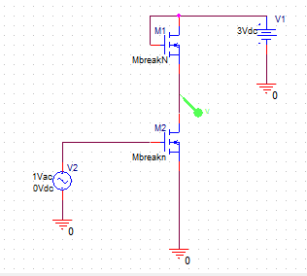

Figure 1. Pspice circuit

Then, we use DC sweep in Pspice to get $V_{OUT}$ vs $V_{IN}$ (Figure 2).

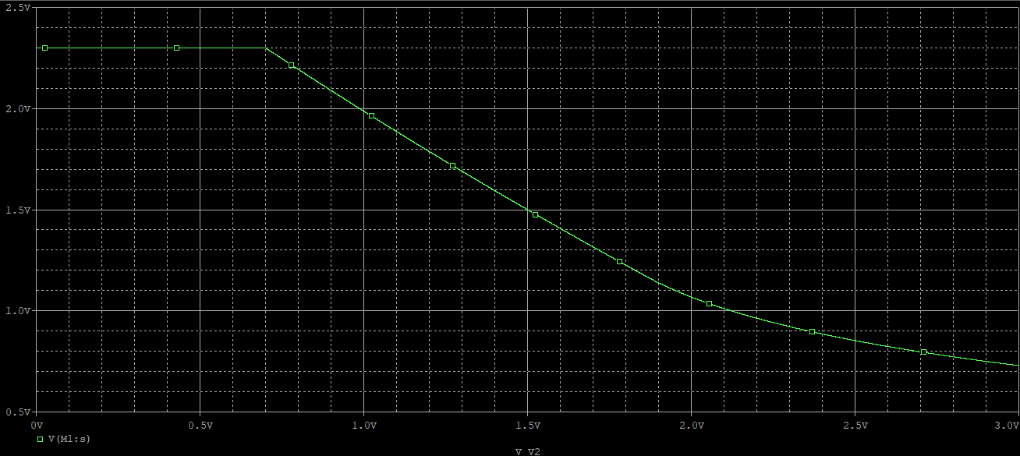

Figure 2. DC sweep

From the figure, we can get (0.99, 1.9972), (1.01, 1.9769), and we can get $A_{v}$ at $V_{IN}=1 V$ as follows:

$$A_{v}={slope}_{1}=\frac{1.9769-1.9972}{1.01-0.99}=-1.015.$$

In lab, we get the following data (Table 1).

|  |  |
| --- | --- |
| $V_{IN}$ (V) | $V_{OUT}$ (V) |
| 0.1 | 2.354 |
| 0.2 | 2.335 |
| 0.3 | 2.316 |
| 0.4 | 2.197 |
| 0.5 | 2.007 |
| 0.6 | 1.809 |
| 0.7 | 1.612 |
| 0.8 | 1.42 |
| 0.9 | 1.234 |
| 1.0 | 1.057 |
| 1.1 | 0.907 |
| 1.2 | 0.799 |
| 1.3 | 0.739 |
| 1.4 | 0.702 |
| 1.5 | 0.675 |
| 2.0 | 0.605 |
| 2.5 | 0.572 |
| 3.0 | 0.55 |

Table 1. Measurement result

And we can get the following plot (Figure 3).

Figure 3. $V_{OUT}$ vs $V_{IN}$ for measurement result

We can calculate the voltage gain at 0.75 is -1.92.

1. In this case, we modify the circuit. In Pspice, we can get the following figure (Figure 4).

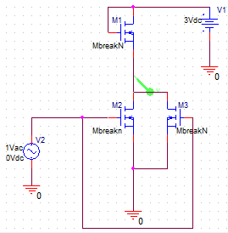

Figure 4. Pspice circuit

Then, we use DC sweep in Pspice to get $V_{OUT}$ vs $V_{IN}$ (Figure 5).

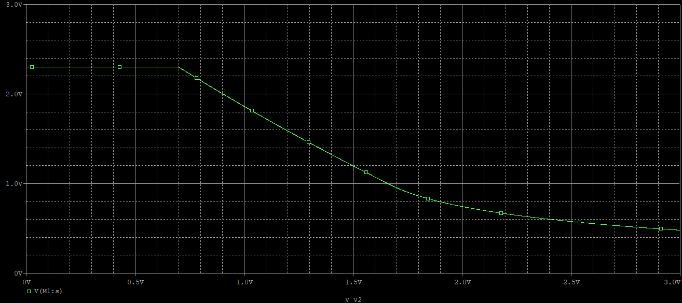

Figure 5. DC sweep

From the figure, we can get (0.99, 1.8762), (1.01, 1.8481), and we can get

$$A_{v}={slope}_{1}=\frac{1.8481-1.8762}{1.01-0.99}=-1.405.$$

It does not double. Previously, (||||||). Now, (||||||||). Therefore, the new $A_{v}$ is not double of the previous $A_{v}$.

In lab, we get the following data (Table 2).

|  |  |
| --- | --- |
| $V_{IN}$ (V) | $V_{OUT}$ (V) |
| 0.1 | 2.365 |
| 0.2 | 2.344 |
| 0.3 | 2.313 |
| 0.4 | 2.175 |
| 0.5 | 1.976 |
| 0.6 | 1.763 |
| 0.7 | 1.524 |
| 0.8 | 1.267 |
| 0.9 | 1.006 |
| 1.0 | 0.75 |
| 1.1 | 0.563 |
| 1.2 | 0.473 |
| 1.3 | 0.425 |
| 1.4 | 0.395 |
| 1.5 | 0.372 |
| 2.0 | 0.312 |
| 2.5 | 0.284 |
| 3.0 | 0.266 |

Table 2. Measurement result

And we can get the following plot (Figure 6).

Figure 6. $V_{OUT}$ vs $V_{IN}$ for measurement result

We can calculate the voltage gain at 0.75 is -2.57.

It also does not double. Previously, (||||||). Now, (||||||||). Therefore, the new $A_{v}$ is not double of the previous $A_{v}$.

1. In Pspice, we use $V_{in}=1.0+0.01sin(2π{10}^{2}∙time)$ and get the following figure (Figure 7).

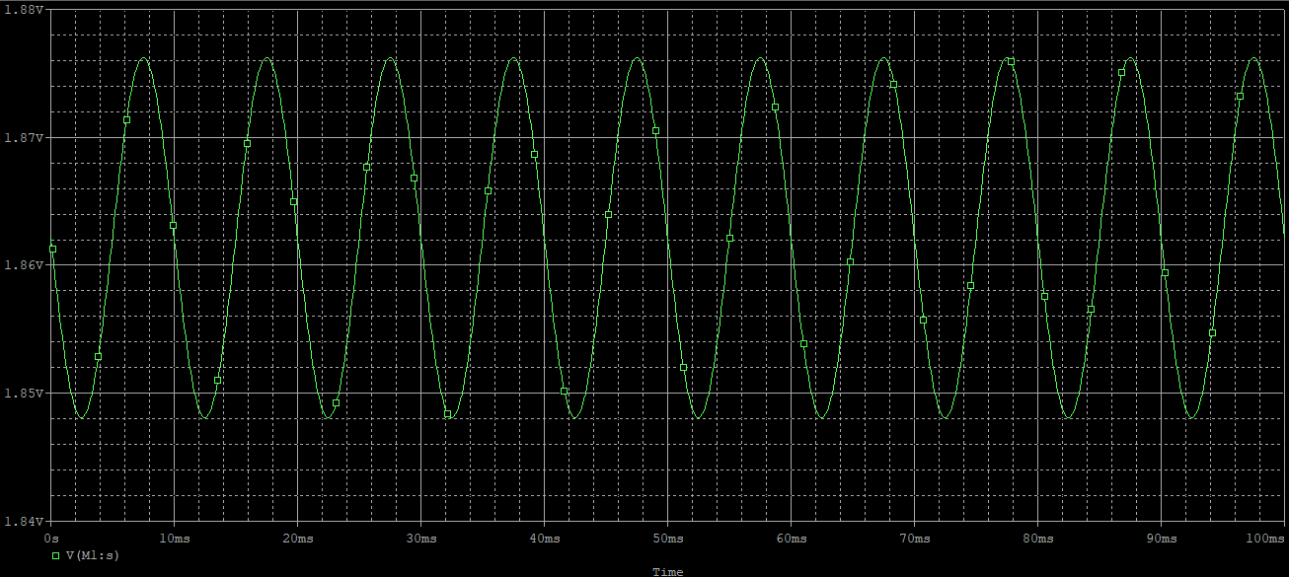

Figure 7. Simulation result

Using cursor, we can get

$$v_{out}=\frac{1.8762-1.8481}{2}=0.01405.$$

Also, from **(b)**, we have

$$0.01×\left|A_{v}\right|=0.01×1.405=0.01405.$$

They are close. Therefore, we can confirm that the amplitude of $v_{out}$ is close to $0.01×A_{v}$.

In lab, since 0.01 is too small to generate and measure, we use $V_{in}=0.75+0.1sin(2π{10}^{2}∙time)$ instead and get the following figure (Figure 8).

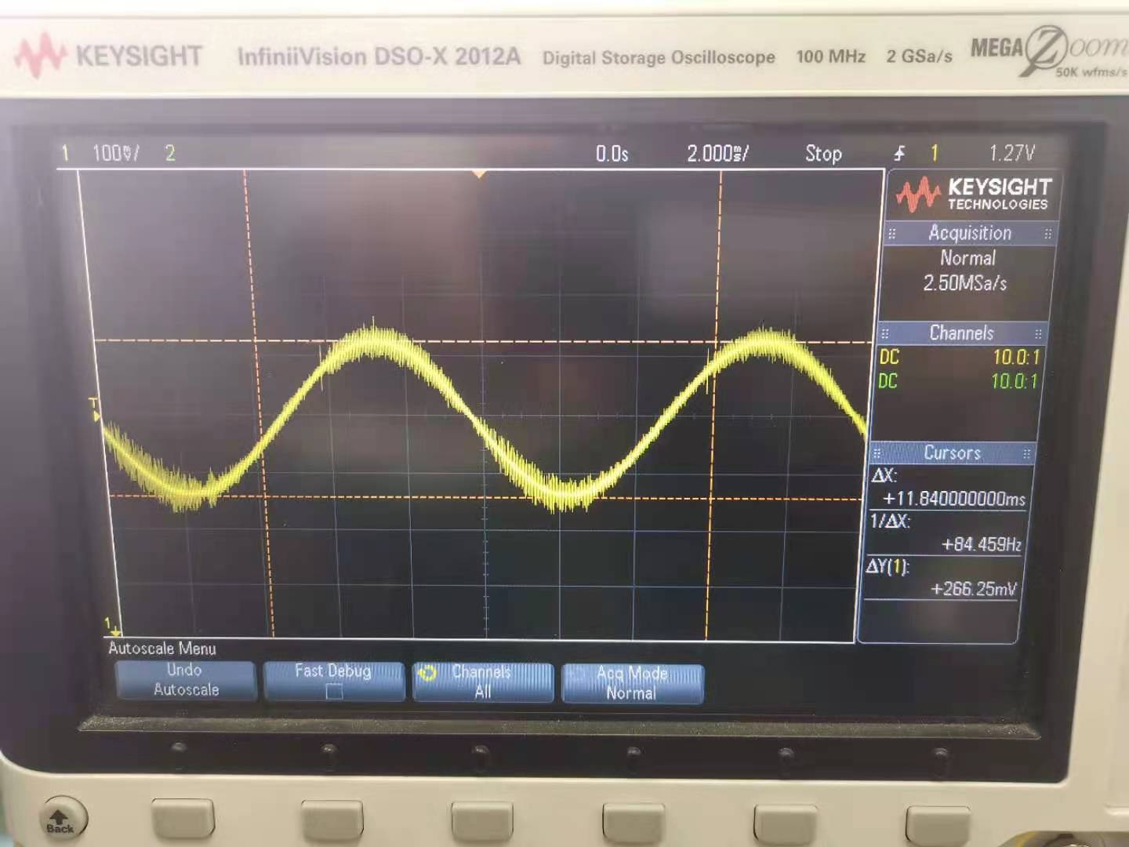

Figure 8. Measurement result for $V_{in}=0.75+0.1sin(2π{10}^{2}∙time)$

We can get that $v_{out}=0.133125 V$. However, it is smaller than $0.1×\left|A_{v}\right|=0.1×2.57=0.257$. It may be because that the circuit is not ideal and has inner resistance.

1. **Common-Source with PMOS Diode-Connected Load**
2. In this part, we first build the circuit below (Figure 9) in Pspice.

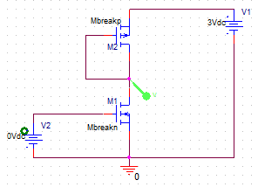

Figure 9. Pspice circuit

Then, we use DC sweep in Pspice to get $V_{OUT}$ vs $V_{IN}$ (Figure 10).

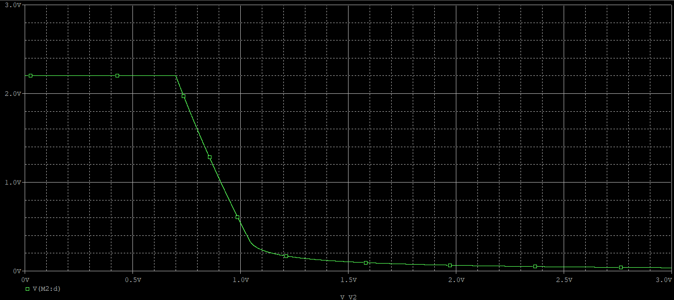

Figure 10. DC sweep

From the figure, we can get (0.89, 1.0990), (0.91, 0.994186), and we can get $A_{v}$ at $V_{IN}=0.9 V$ as follows:

$$A_{v}={slope}_{0.9}=\frac{0.994186-1.0990}{0.91-0.89}=-5.2407.$$

In lab, we get the following data (Table 3).

|  |  |
| --- | --- |
| $V_{IN}$ (V) | $V_{OUT}$ (V) |
| 0.1 | 1.516 |
| 0.2 | 1.522 |
| 0.3 | 1.474 |
| 0.4 | 1.29 |
| 0.5 | 1.03 |
| 0.6 | 0.769 |
| 0.7 | 0.504 |
| 0.8 | 0.258 |
| 0.9 | 0.155 |
| 1.0 | 0.122 |
| 1.1 | 0.105 |
| 1.2 | 0.095 |
| 1.3 | 0.089 |
| 1.4 | 0.083 |
| 1.5 | 0.079 |
| 2.0 | 0.066 |
| 2.5 | 0.06 |
| 3.0 | 0.056 |

Table 3. Measurement result

And we can get the following plot (Figure 11).

Figure 11. $V_{OUT}$ vs $V_{IN}$ for measurement result

We can calculate the voltage gain at 0. 5 is -2.6.

1. In this case, we modify the circuit. In Pspice, we can get the following figure (Figure 12).

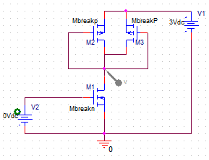

Figure 12. Pspice circuit

Then, we use DC sweep in Pspice to get $V_{OUT}$ vs $V_{IN}$ (Figure 13).

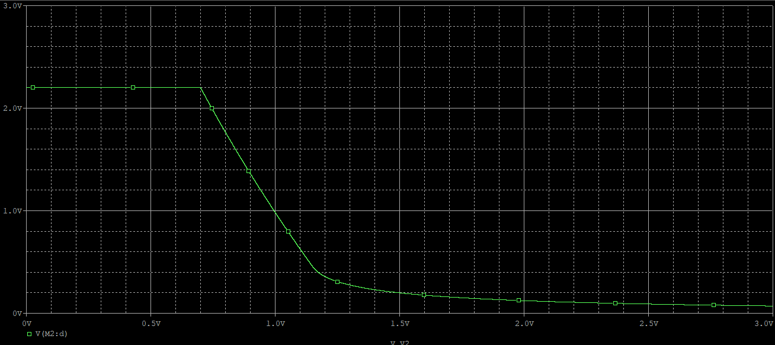

Figure 13. DC sweep

From the figure, we can get (0.89, 1.4008), (0.91, 1.3226), and we can get $A_{v}$ at $V_{IN}=0.9 V$ as follows:

$$A_{v}={slope}_{0.9}=\frac{1.3226-1.4008}{0.91-0.89}=-3.91.$$

We can find that the absolute value of voltage gain becomes smaller. The reason may be that previously, (||). But, now, (||||). Therefore, the absolute value of new voltage is smaller.

In lab, we get the following data (Table 4).

|  |  |
| --- | --- |
| $V_{IN}$ (V) | $V_{OUT}$ (V) |
| 0.1 | 1.548 |
| 0.2 | 1.541 |
| 0.3 | 1.503 |
| 0.4 | 1.324 |
| 0.5 | 1.068 |
| 0.6 | 0.824 |
| 0.7 | 0.596 |
| 0.8 | 0.389 |
| 0.9 | 0.255 |
| 1.0 | 0.203 |
| 1.1 | 0.179 |
| 1.2 | 0.166 |
| 1.3 | 0.155 |
| 1.4 | 0.148 |
| 1.5 | 0.14 |
| 2.0 | 0.123 |
| 2.5 | 0.115 |
| 3.0 | 0.109 |

Table 4. Measurement result

And we can get the following plot (Figure 14).

Figure 14. $V_{OUT}$ vs $V_{IN}$ for measurement result

We can calculate the voltage gain at 0. 5 is -2.56, whose absolute value is smaller than the previous one. The reason may be the same. Previously, (||). But, now, (||||). Therefore, the absolute value of new voltage is smaller.

1. In Pspice, we use $V_{in}=0.9+0.01sin(2π{10}^{2}∙time)$ and get the following figure (Figure 15).

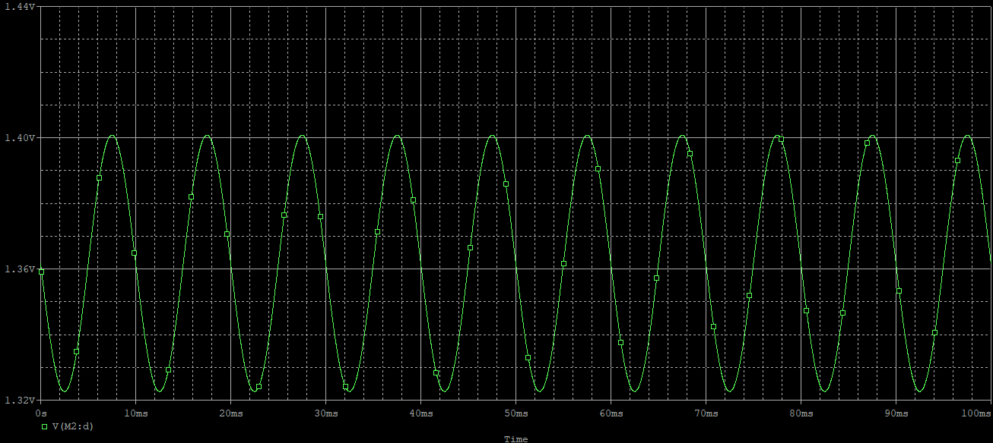

Figure 15. Simulation result

Using cursor, we can get

$$v_{out}=\frac{1.4007-1.3226}{2}=0.03905.$$

Also, from **(b)**, we have

$$0.01×\left|A_{v}\right|=0.01×3.91=0.0391.$$

They are close. Therefore, we can confirm that the amplitude of $v_{out}$ is close to $0.01×A_{v}$.

In lab, since 0.01 is too small to generate and measure, we use $V_{in}=0.5+0.1sin(2π{10}^{2}∙time)$ instead and get the following figure (Figure 16).

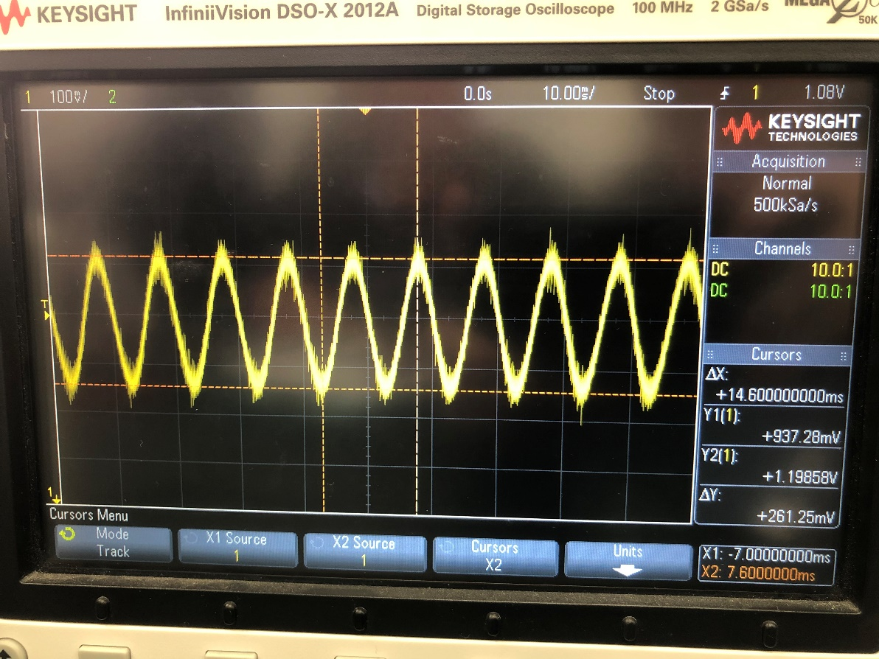

Figure 16. Measurement result for $V_{in}=0.5+0.1sin(2π{10}^{2}∙time)$

We can get that $v_{out}=0.130625 V$. However, it is larger than $0.1×\left|A_{v}\right|=0.1×2.56=0.256$. It may be because that the circuit is not ideal and has inner resistance.